**Entregable 2**

**Alumnos:**

* **Luis Alberto Álvarez Zavaleta**
* **David Arnal García**

**Ejercicio 1**

Para el caso separable con (*trSep.dat*, *trSeplabels.dat*) y *C* = 1000:

* Coeficientes de *Lagrange* = [0.87472 0.74989 -1.62461].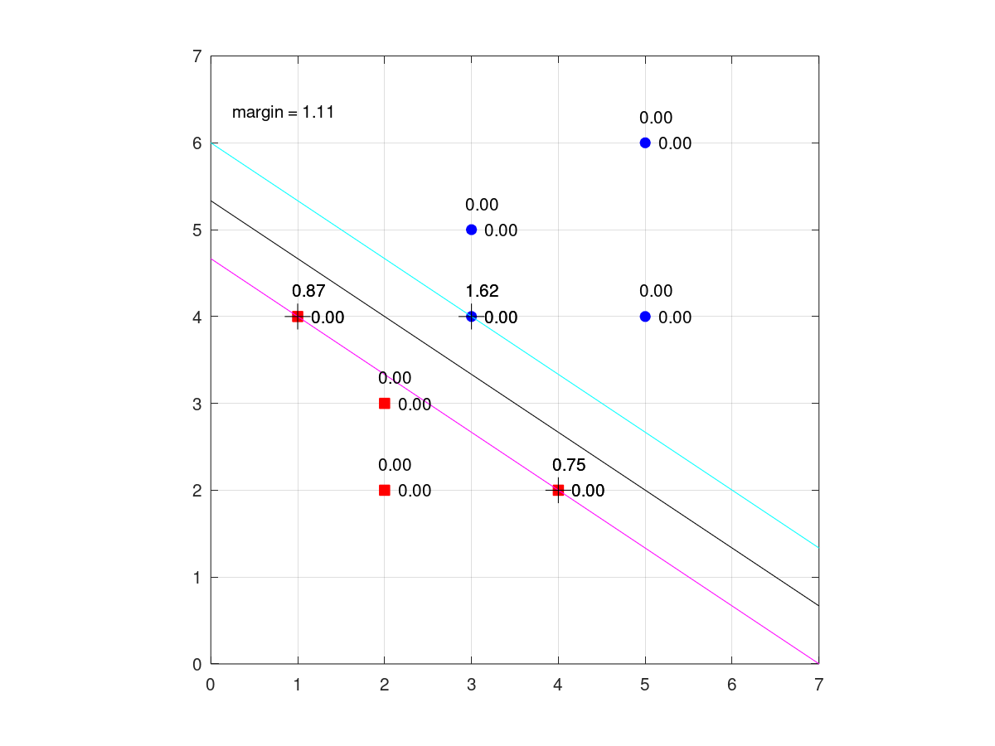
* Vector soporte
  + (1, 1) -> 1
  + (2, 1) -> 4
  + (3, 1) -> 3
  + (1, 2) -> 4
  + (2, 2) -> 2
  + (3, 2) -> 4
* Vector de pesos = [-0.99955 -1.49978].
* Umbral de la función discriminante = 7.9987.
* Margen = 1.1097.
* Función discriminante -> *y* = -(0.66647)x - (-5.3332).

Para el caso no separable con y *C* = 1:

* Coeficientes de *Lagrange* = [0.65306 0.73472 1.0 -1.0 -0.38778 -1.0].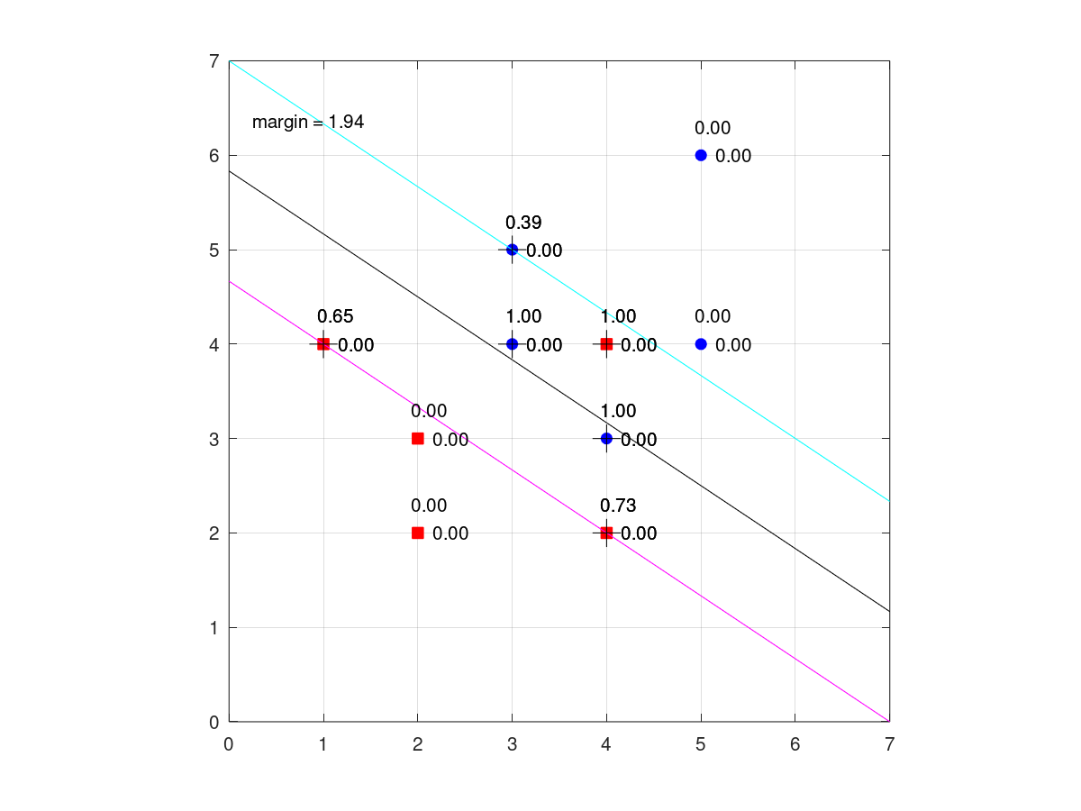
* Vector soporte
  + (1, 1) -> 1
  + (2, 1) -> 4
  + (3, 1) -> 4
  + (4, 1) -> 3
  + (5, 1) -> 3
  + (6, 1) -> 4
  + (1, 2) -> 4
  + (2, 2) -> 2
  + (3, 2) -> 4
  + (4, 2) -> 4
  + (5, 2) -> 5
  + (6, 2) -> 3
* Vector de pesos = [-0.57139 -0.85722].
* Umbral de la función discriminante = 5.0003.
* Margen = 1.9414.
* Función discriminante -> *y* = -(0.66657)x -(-5.8331).

Para el caso no separable con y *C* = 100:

* Coeficiente de *Lagrange* = [25.875 50.750 100.0 -76.625 -100.0].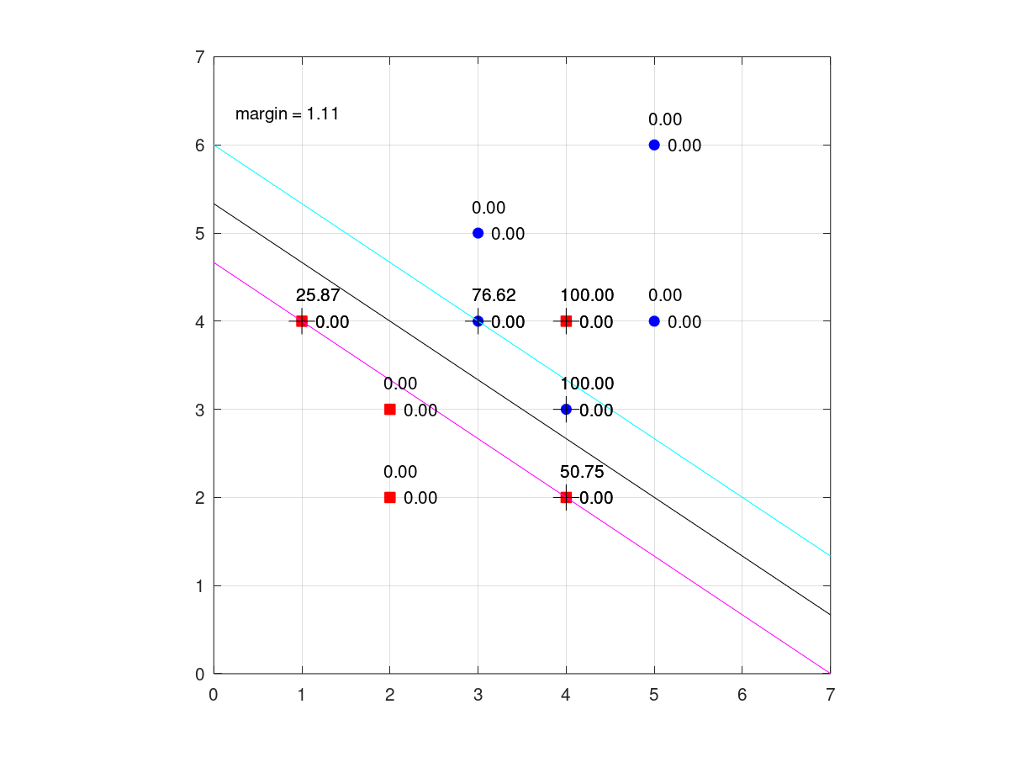
* Vector soporte
  + (1, 1) -> 1
  + (2, 1) -> 4
  + (3, 1) -> 4
  + (4, 1) -> 3
  + (5, 1) -> 4
  + (1, 2) -> 4
  + (2, 2) -> 2
  + (3, 2) -> 4
  + (4, 2) -> 4
  + (5, 2) -> 3
* Vector de pesos = [-0.99955 -1.49978].
* Umbral = 7.9987.
* Margen = 1.1097.
* Función discriminante -> *y* = -(0.66647)x -(-5.3332)

Para el caso no separable con y *C* = 1000:

* Coeficiente de *Lagrange* = [250.87 500.75 1000.00 -751.62 -1000.00].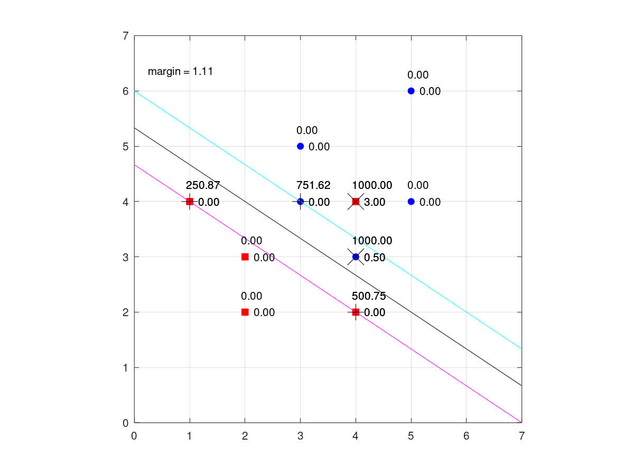
* Vector soporte
  + (1, 1) -> 1
  + (2, 1) -> 4
  + (3, 1) -> 4
  + (4, 1) -> 3
  + (5, 1) -> 4
  + (1, 2) -> 4
  + (2, 2) -> 2
  + (3, 2) -> 4
  + (4, 2) -> 4
  + (5, 2) -> 3
* Vector de pesos = [-0.99955 -1.49977].
* Umbral = 7.9986.
* Margen = 1.1097.
* Función discriminante -> *y* = -( 0.66647)x -(-5.3332).

**Ejercicio 2**

Ver anexo para visualizar todos los resultados obtenidos por pca+svm-exp.m

PCA = 50

| T | C | G | acierto | intervalo |
| --- | --- | --- | --- | --- |
| 2 | 100 | 0.1 | 0.950000 | 0.001744 |
| 2 | 100 | 0.01 | 0.961667 | 0.001536 |
| 2 | 100 | 0.001 | 0.946667 | 0.001798 |
| 2 | 100 | 0.0001 | 0.921667 | 0.002150 |
| 2 | 100 | 1,00E-05 | 0.906667 | 0.002328 |

PCA = 100

| T | C | G | acierto | intervalo |
| --- | --- | --- | --- | --- |
| 2 | 100 | 0.1 | 0.910000 | 0.002290 |
| 2 | 100 | 0.01 | 0.968333 | 0.001401 |
| 2 | 100 | 0.001 | 0.928333 | 0.002064 |
| 2 | 100 | 0.0001 | 0.928333 | 0.002064 |
| 2 | 100 | 1,00E-05 | 0.906667 | 0.002328 |

PCA = 200

| T | C | G | acierto | intervalo |
| --- | --- | --- | --- | --- |
| 2 | 10 | 0.1 | 0.860000 | 0.002776 |
| 2 | 10 | 0.01 | 0.968333 | 0.001401 |
| 2 | 10 | 0.001 | 0.933333 | 0.001996 |
| 2 | 10 | 0.0001 | 0.911667 | 0.002271 |
| 2 | 10 | 1,00E-05 | 0.778333 | 0.003324 |

Los mejores resultados que hemos obtenido han sido con un *Kernel Gaussiano* (T=2) aplicando *PCA* = 50 con *C* = 100 y *PCA* = 100 con *C* = 10 y un valor *gamma* *G* = 0.01.Por lo que usaremos estos valores para la parte de evaluación , además.Hemos podido observar que, al aplicar *PCA* para la solución óptima y proyectando a pocas dimensiones, empeora el valor óptimo.

**Ejercicio 3**

PCA = 100

| T | C | G | acierto | intervalo |
| --- | --- | --- | --- | --- |
| 2 | 10 | 0.01 | 98.370 | [98.112 98.618] |
| 2 | 100 | 0.01 | 98.350 | [98.100 98.600] |

PCA = 200

| T | C | G | acierto | intervalo |
| --- | --- | --- | --- | --- |
| 2 | 10 | 0.01 | 98.280 | [98.025 98.535] |
| 2 | 100 | 0.01 | 98.280 | [98.025 98.535] |

Al ejecutar *pca+svm-eva.m* para un *Kernel Gaussiano* (T=2) aplicando *PCA* = 50 o *PCA* = 100 y con *C* = 100 o *C* = 10 y un valor *gamma* *G* = 0.01. Hemos observado que los parámetros que mejor resultado nos ofrecen son *PCA* = 100, *T* = 2, *C* = 10 y *G* = 0.01 con un error de clasificación del 1.63% al compararlo con el de *MNIST,* que es de un 1.4%.



**ANEXO**

PCA = 50

| T | C | acierto | intervalo |
| --- | --- | --- | --- |
| 0 | 1 | 0.925000 | 0.002108 |

| T | C | D | acierto | intervalo |
| --- | --- | --- | --- | --- |
| 1 | 1 | 1 | 0.920000 | 0.002171 |
| 1 | 1 | 2 | 0.961667 | 0.001536 |
| 1 | 1 | 3 | 0.950000 | 0.001744 |
| 1 | 1 | 4 | 0.926667 | 0.002086 |
| 1 | 1 | 5 | 0.893333 | 0.002470 |

| T | C | G | acierto | intervalo |
| --- | --- | --- | --- | --- |
| 2 | 1 | 0.1 | 0.945000 | 0.001824 |
| 2 | 1 | 0.01 | 0.956667 | 0.001629 |
| 2 | 1 | 0.001 | 0.910000 | 0.002290 |
| 2 | 1 | 0.0001 | 0.773333 | 0.003350 |
| 2 | 1 | 1,00E-05 | 0.123333 | 0.002631 |

| T | C | G | acierto | intervalo |
| --- | --- | --- | --- | --- |
| 3 | 1 | 0.1 | 0.503333 | 0.004001 |
| 3 | 1 | 0.01 | 0.916667 | 0.002212 |
| 3 | 1 | 0.001 | 0.888333 | 0.002520 |
| 3 | 1 | 0.0001 | 0.508333 | 0.004000 |
| 3 | 1 | 1,00E-05 | 0.123333 | 0.002631 |

| T | C | acierto | intervalo |
| --- | --- | --- | --- |
| 0 | 10 | 0.911667 | 0.002271 |

| T | C | D | acierto | intervalo |
| --- | --- | --- | --- | --- |
| 1 | 10 | 1 | 0.923333 | 0.002129 |
| 1 | 10 | 2 | 0.951667 | 0.001716 |
| 1 | 10 | 3 | 0.958333 | 0.001599 |
| 1 | 10 | 4 | 0.941667 | 0.001875 |
| 1 | 10 | 5 | 0.941667 | 0.001875 |

| T | C | G | acierto | intervalo |
| --- | --- | --- | --- | --- |
| 2 | 10 | 0.1 | 0.950000 | 0.001744 |
| 2 | 10 | 0.01 | 0.960000 | 0.001568 |
| 2 | 10 | 0.001 | 0.920000 | 0.002171 |
| 2 | 10 | 0.0001 | 0.906667 | 0.002328 |
| 2 | 10 | 1,00E-05 | 0.775000 | 0.003341 |

| T | C | G | acierto | intervalo |
| --- | --- | --- | --- | --- |
| 3 | 10 | 0.1 | 0.488333 | 0.004000 |
| 3 | 10 | 0.01 | 0.913333 | 0.002251 |
| 3 | 10 | 0.001 | 0.921667 | 0.002150 |
| 3 | 10 | 0.0001 | 0.888333 | 0.002520 |
| 3 | 10 | 1,00E-05 | 0.508333 | 0.004000 |

| T | C | acierto | intervalo |
| --- | --- | --- | --- |
| 0 | 100 | 0.905000 | 0.002346 |

| T | C | D | acierto | intervalo |
| --- | --- | --- | --- | --- |
| 1 | 100 | 1 | 0.908333 | 0.002309 |
| 1 | 100 | 2 | 0.953333 | 0.001688 |
| 1 | 100 | 3 | 0.958333 | 0.001599 |
| 1 | 100 | 4 | 0.940000 | 0.001900 |
| 1 | 100 | 5 | 0.930000 | 0.002042 |

| T | C | G | acierto | intervalo |
| --- | --- | --- | --- | --- |
| 2 | 100 | 0.1 | 0.950000 | 0.001744 |
| 2 | 100 | 0.01 | 0.961667 | 0.001536 |
| 2 | 100 | 0.001 | 0.946667 | 0.001798 |
| 2 | 100 | 0.0001 | 0.921667 | 0.002150 |
| 2 | 100 | 1,00E-05 | 0.906667 | 0.002328 |

| T | C | G | acierto | intervalo |
| --- | --- | --- | --- | --- |
| 3 | 100 | 0.1 | 0.503333 | 0.004001 |
| 3 | 100 | 0.01 | 0.888333 | 0.002520 |
| 3 | 100 | 0.001 | 0.930000 | 0.002042 |
| 3 | 100 | 0.0001 | 0.921667 | 0.002150 |
| 3 | 100 | 1,00E-05 | 0.888333 | 0.002520 |

PCA = 100

| T | C | acierto | intervalo |
| --- | --- | --- | --- |
| 0 | 1 | 0.906667 | 0.002328 |

| T | C | D | acierto | intervalo |
| --- | --- | --- | --- | --- |
| 1 | 1 | 1 | 0.923333 | 0.002129 |
| 1 | 1 | 2 | 0.953333 | 0.001688 |
| 1 | 1 | 3 | 0.896667 | 0.002436 |
| 1 | 1 | 4 | 0.518333 | 0.003998 |
| 1 | 1 | 5 | 0.246667 | 0.003449 |

| T | C | G | acierto | intervalo |
| --- | --- | --- | --- | --- |
| 2 | 1 | 0.1 | 0.906667 | 0.002328 |
| 2 | 1 | 0.01 | 0.961667 | 0.001536 |
| 2 | 1 | 0.001 | 0.913333 | 0.002251 |
| 2 | 1 | 0.0001 | 0.775000 | 0.003341 |
| 2 | 1 | 1,00E-05 | 0.123333 | 0.002631 |

| T | C | G | acierto | intervalo |
| --- | --- | --- | --- | --- |
| 3 | 1 | 0.1 | 0.508333 | 0.004000 |
| 3 | 1 | 0.01 | 0.918333 | 0.002191 |
| 3 | 1 | 0.001 | 0.893333 | 0.002470 |
| 3 | 1 | 0.0001 | 0.508333 | 0.004000 |
| 3 | 1 | 1,00E-05 | 0.123333 | 0.002631 |

| T | C | acierto | intervalo |
| --- | --- | --- | --- |
| 0 | 10 | 0.888333 | 0.002520 |

| T | C | D | acierto | intervalo |
| --- | --- | --- | --- | --- |
| 1 | 10 | 1 | 0.913333 | 0.002251 |
| 1 | 10 | 2 | 0.960000 | 0.001568 |
| 1 | 10 | 3 | 0.958333 | 0.001599 |
| 1 | 10 | 4 | 0.923333 | 0.002129 |
| 1 | 10 | 5 | 0.756667 | 0.003433 |

| T | C | G | acierto | intervalo |
| --- | --- | --- | --- | --- |
| 2 | 10 | 0.1 | 0.910000 | 0.002290 |
| 2 | 10 | 0.01 | 0.965000 | 0.001471 |
| 2 | 10 | 0.001 | 0.930000 | 0.002042 |
| 2 | 10 | 0.0001 | 0.906667 | 0.002328 |
| 2 | 10 | 1,00E-05 | 0.776667 | 0.003333 |

| T | C | G | acierto | intervalo |
| --- | --- | --- | --- | --- |
| 3 | 10 | 0.1 | 0.505000 | 0.004001 |
| 3 | 10 | 0.01 | 0.906667 | 0.002328 |
| 3 | 10 | 0.001 | 0.923333 | 0.002129 |
| 3 | 10 | 0.0001 | 0.893333 | 0.002470 |
| 3 | 10 | 1,00E-05 | 0.508333 | 0.004000 |

| T | C | acierto | intervalo |
| --- | --- | --- | --- |
| 0 | 100 | 0.890000 | 0.002504 |

| T | C | D | acierto | intervalo |
| --- | --- | --- | --- | --- |
| 1 | 100 | 1 | 0.906667 | 0.002328 |
| 1 | 100 | 2 | 0.958333 | 0.001599 |
| 1 | 100 | 3 | 0.961667 | 0.001536 |
| 1 | 100 | 4 | 0.943333 | 0.001850 |
| 1 | 100 | 5 | 0.933333 | 0.001996 |

| T | C | G | acierto | intervalo |
| --- | --- | --- | --- | --- |
| 2 | 100 | 0.1 | 0.910000 | 0.002290 |
| 2 | 100 | 0.01 | 0.968333 | 0.001401 |
| 2 | 100 | 0.001 | 0.928333 | 0.002064 |
| 2 | 100 | 0.0001 | 0.928333 | 0.002064 |
| 2 | 100 | 1,00E-05 | 0.906667 | 0.002328 |

| T | C | G | acierto | intervalo |
| --- | --- | --- | --- | --- |
| 3 | 100 | 0.1 | 0.505000 | 0.004001 |
| 3 | 100 | 0.01 | 0.876667 | 0.002631 |
| 3 | 100 | 0.001 | 0.913333 | 0.002251 |
| 3 | 100 | 0.0001 | 0.923333 | 0.002129 |
| 3 | 100 | 1,00E-05 | 0.893333 | 0.002470 |

PCA = 200

| T | C | acierto | intervalo |
| --- | --- | --- | --- |
| 0 | 1 | 0.901667 | 0.002383 |

| T | C | D | acierto | intervalo |
| --- | --- | --- | --- | --- |
| 1 | 1 | 1 | 0.916667 | 0.002212 |
| 1 | 1 | 2 | 0.905000 | 0.002346 |
| 1 | 1 | 3 | 0.391667 | 0.003906 |
| 1 | 1 | 4 | 0.138333 | 0.002763 |
| 1 | 1 | 5 | 0.123333 | 0.002631 |

| T | C | G | acierto | intervalo |
| --- | --- | --- | --- | --- |
| 2 | 1 | 0.1 | 0.846667 | 0.002883 |
| 2 | 1 | 0.01 | 0.960000 | 0.001568 |
| 2 | 1 | 0.001 | 0.913333 | 0.002251 |
| 2 | 1 | 0.0001 | 0.776667 | 0.003333 |
| 2 | 1 | 1,00E-05 | 0.123333 | 0.002631 |

| T | C | G | acierto | intervalo |
| --- | --- | --- | --- | --- |
| 3 | 1 | 0.1 | 0.526667 | 0.003995 |
| 3 | 1 | 0.01 | 0.923333 | 0.002129 |
| 3 | 1 | 0.001 | 0.895000 | 0.002453 |
| 3 | 1 | 0.0001 | 0.510000 | 0.004000 |
| 3 | 1 | 1,00E-05 | 0.123333 | 0.002631 |

| T | C | acierto | intervalo |
| --- | --- | --- | --- |
| 0 | 10 | 0.898333 | 0.002418 |

| T | C | D | acierto | intervalo |
| --- | --- | --- | --- | --- |
| 1 | 10 | 1 | 0.923333 | 0.002129 |
| 1 | 10 | 2 | 0.965000 | 0.001471 |
| 1 | 10 | 3 | 0.906667 | 0.002328 |
| 1 | 10 | 4 | 0.430000 | 0.003961 |
| 1 | 10 | 5 | 0.165000 | 0.002970 |

| T | C | G | acierto | intervalo |
| --- | --- | --- | --- | --- |
| 2 | 10 | 0.1 | 0.860000 | 0.002776 |
| 2 | 10 | 0.01 | 0.968333 | 0.001401 |
| 2 | 10 | 0.001 | 0.933333 | 0.001996 |
| 2 | 10 | 0.0001 | 0.911667 | 0.002271 |
| 2 | 10 | 1,00E-05 | 0.778333 | 0.003324 |

| T | C | G | acierto | intervalo |
| --- | --- | --- | --- | --- |
| 3 | 10 | 0.1 | 0.513333 | 0.003999 |
| 3 | 10 | 0.01 | 0.915000 | 0.002232 |
| 3 | 10 | 0.001 | 0.926667 | 0.002086 |
| 3 | 10 | 0.0001 | 0.895000 | 0.002453 |
| 3 | 10 | 1,00E-05 | 0.510000 | 0.004000 |

| T | C | acierto | intervalo |
| --- | --- | --- | --- |
| 0 | 100 | 0.898333 | 0.002418 |

| T | C | D | acierto | intervalo |
| --- | --- | --- | --- | --- |
| 1 | 100 | 1 | 0.900000 | 0.002400 |
| 1 | 100 | 2 | 0.953333 | 0.001688 |
| 1 | 100 | 3 | 0.965000 | 0.001471 |
| 1 | 100 | 4 | 0.906667 | 0.002328 |
| 1 | 100 | 5 | 0.491667 | 0.004000 |

| T | C | G | acierto | intervalo |
| --- | --- | --- | --- | --- |
| 2 | 100 | 0.1 | 0.860000 | 0.002776 |
| 2 | 100 | 0.01 | 0.965000 | 0.001471 |
| 2 | 100 | 0.001 | 0.936667 | 0.001949 |
| 2 | 100 | 0.0001 | 0.928333 | 0.002064 |
| 2 | 100 | 1,00E-05 | 0.911667 | 0.002271 |

| T | C | G | acierto | intervalo |
| --- | --- | --- | --- | --- |
| 3 | 100 | 0.1 | 0.516667 | 0.003999 |
| 3 | 100 | 0.01 | 0.883333 | 0.002569 |
| 3 | 100 | 0.001 | 0.926667 | 0.002086 |
| 3 | 100 | 0.0001 | 0.926667 | 0.002086 |
| 3 | 100 | 1,00E-05 | 0.895000 | 0.002453 |